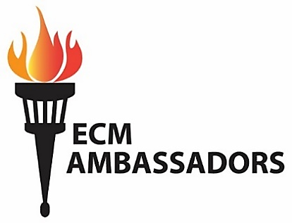
“I was in prison and you visited me.”
(Matthew 25:36)

Episcopal City Mission’s Parish Ambassadors advocate on behalf of our ministry with children in the juvenile justice system. They tell the story of our work, its lasting impact, and empower others to become involved. For the children we serve and our volunteers, our work is transformational!

Advocacy:
    - Provide updates about ECM’s work and events to your congregation: announcements, newsletters, parish website, bulletin boards, attend Ministry/Outreach events to personally engage with others. “Like” us on Facebook and “Share” our posts
    - ECM Annual events: Attend and invite others!
  - Annual Meeting (February): ministry update, elect Board Members, adopt the budget.
PA’s are members of ECM’s corporation and have seat, voice and vote!
  - ECM Sunday (Last Sunday After Epiphany): diocesan event with modified “Prayers of the People,” and education highlighting ECM’s ministry and the children we serve.
  - Spring Walk-a-Thon (April or May): multi-generational FUNdraiser with food, music, games and prizes.
  - Moment in Time Gala & Auction (October): semi-formal event with cocktail reception, music, motivational speaker(s), dinner, Live & Silent Auctions
  - Holiday Gifts (early Advent): Parishes and individuals provide gifts for detained children.
  - Gift Wrapping Party (mid-December): Help wrap and sort the gifts; lunch is served.

Connect others with ECM:
    - Identify people with skills/interest to serve on ECM’s Board, help with fundraisers or events. Talk with them about ECM.
    - Recruit another Parish Ambassador to serve alongside you.
    - Host a fundraiser: Trivia Nights, Game Night, special offerings, etc.

About ECM:
    - Serves children ages 11 thru 17 in St. Louis’ Juvenile Justice System at City and County Detention Centers and Missouri Hills (Division of Youth Services)
    - Provides chaplaincy services and programming that encourage growth/change: pastoral Care, faith-based conversations, chapel services, Bible study, prayer/study resources, books, journals.
    - 501c3 non-profit funded by individuals, churches, Diocese of MO, foundations, grants, fundraisers.
    - Ministry of the Diocese of MO, beginning in 1894 with visits to city institutions (Workhouse, City Hospital, Poor House, Jail). In 1954 the focus became serving youth in detention.
    - congregational support also includes prayers, birthday parties, Goody Bags, journals, holiday gifts, announcements of ECM events, etc.
    - Volunteers: Tutor, Mentor, Library/Program Asst., ECM Board, Parish Ambassador, Event Planning
Interested? Contact us at ecitymission@sbcglobal.net or 314-436-3545
Learn more at www.ecitymission.org

